**Ans to the question number 1**

**A**

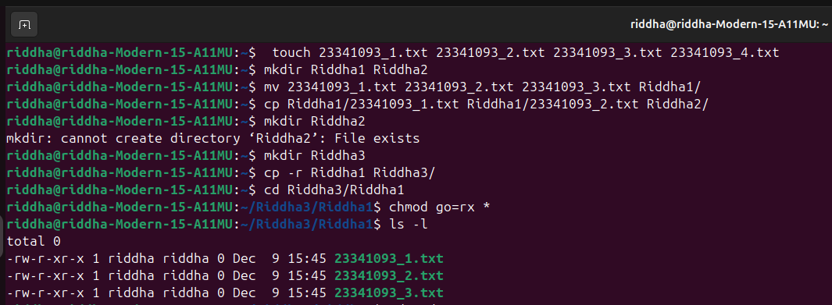

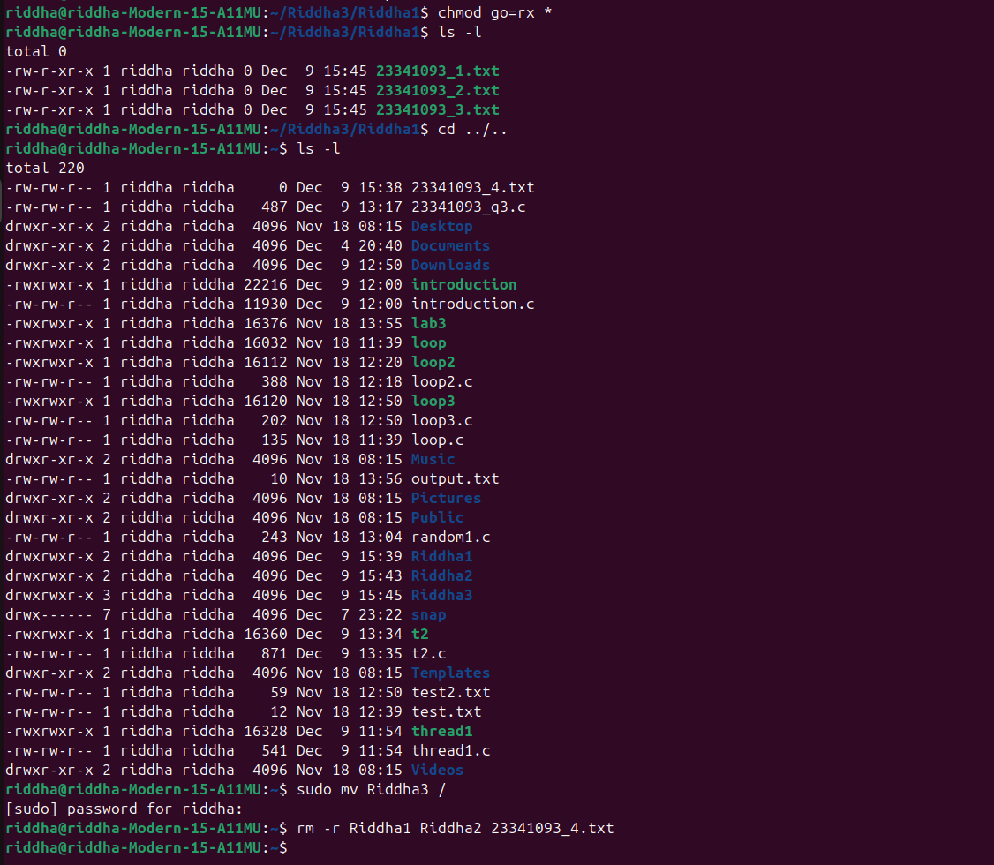

touch 23341093_1.txt 23341093_2.txt 23341093_3.txt 23341093_4.txt

mkdir Riddha1 Riddha2

mv 23341093_1.txt 23341093_2.txt 23341093_3.txt Riddha1/

cp Riddha1/23341093_1.txt Riddha1/23341093_2.txt Riddha2/

mkdir Riddha3

cp -r Riddha1 Riddha3/

cd Riddha3/Riddha1

chmod go=rx *

ls -l

cd ../..

ls -l

sudo mv Riddha3 /

rm -r Riddha1 Riddha2 23341093_4.txt

**B**

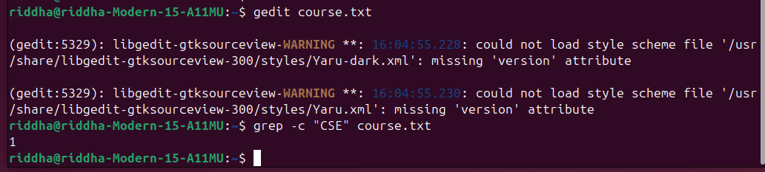

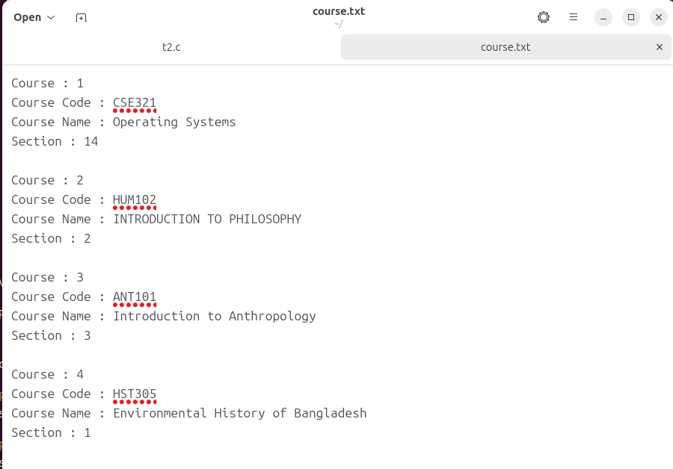

gedit course.txt

grep -c "CSE" course.txt

**C**

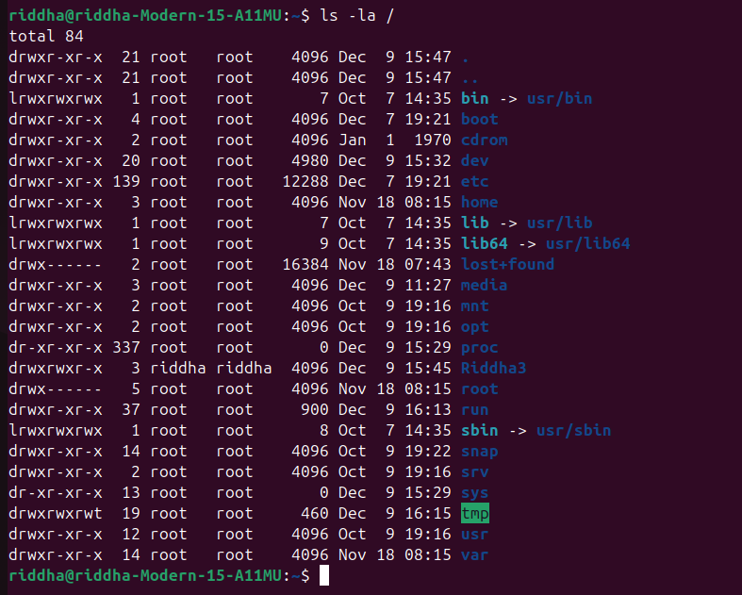

Ls - la /

**D**

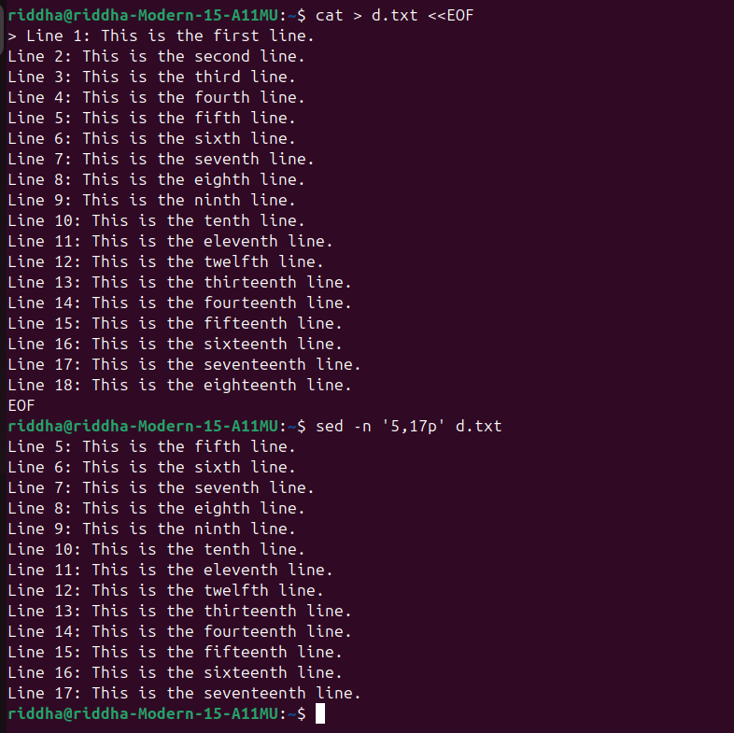

cat > d.txt <<EOF

sed -n '5,17p' d.txt

**Ans to the question number 2**

**A**

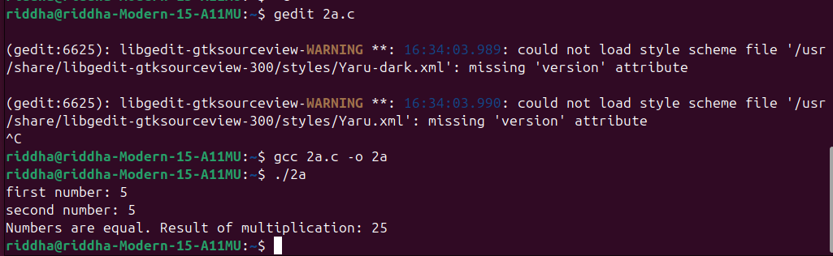

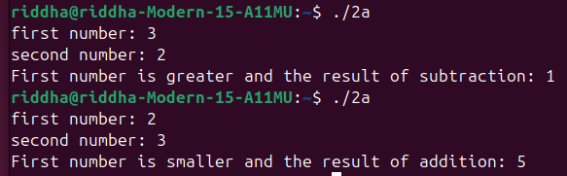

**B**

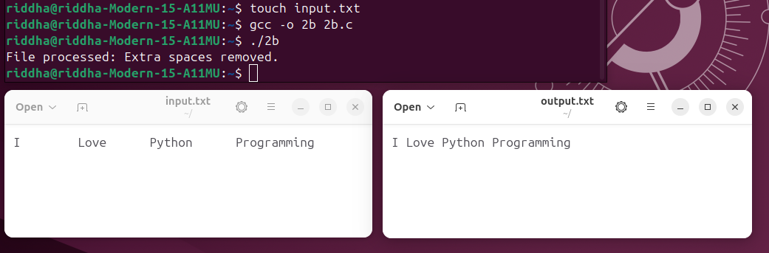

**C**

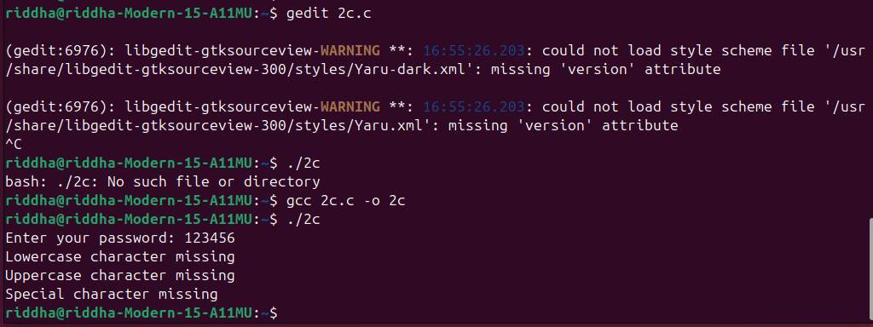







**D**

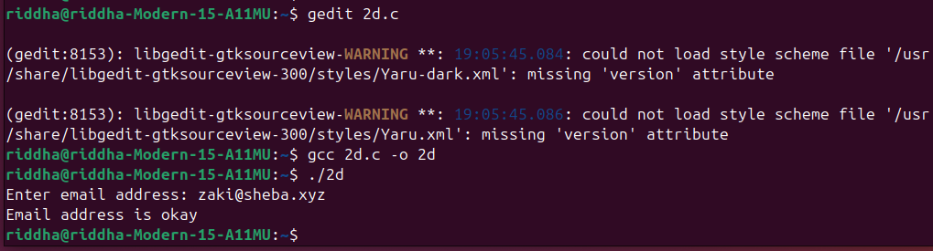

**E**

